**Documentation of Jenkins assignment**

1. Create a master/slave configuration with docker containers.  
   - Install Docker on the workspace  
   - Install Jenkins on the workspace  
   - Use the docker plugin to setup slaves  
   - Create a docker image necessary for the docker slave and setup the docker slave using the plugin.  
   - Create a simple pipeline that executes on the slave.
2. Create a **declarative** pipeline to build docker images and push to Dockerhub.  
   - Create a pipeline with the following stages - 1. Checkout 2. Docker build 3. Approval 3. Docker push

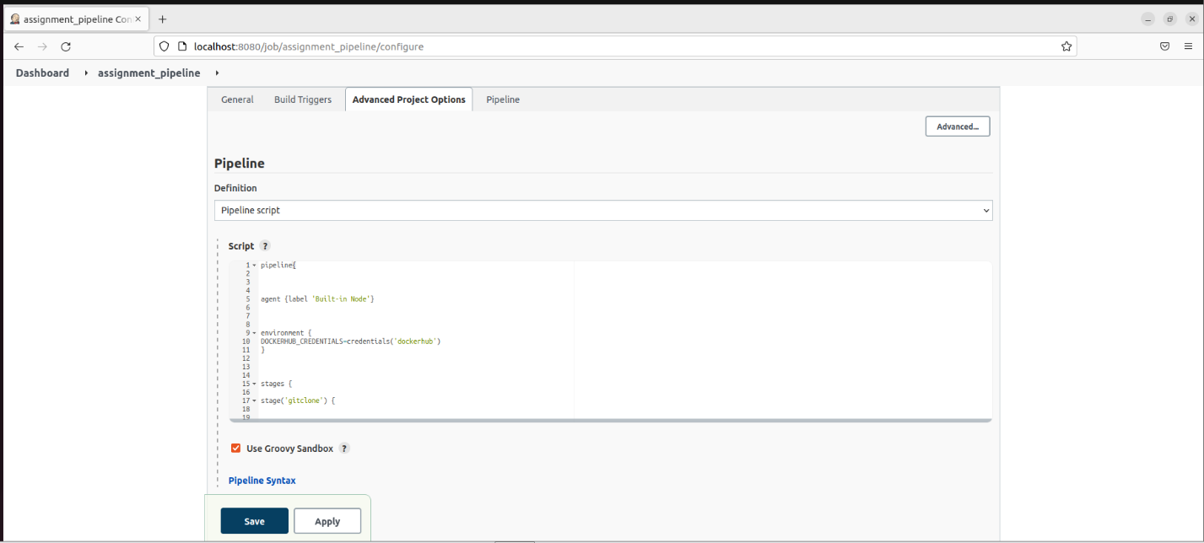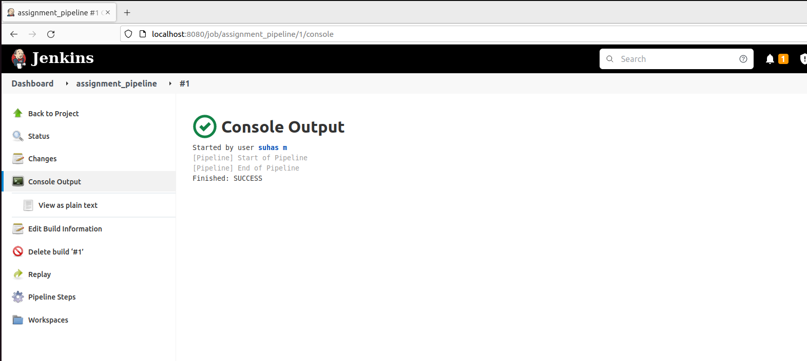

4.Schedule jobs ( cron builds) to execute the pipeline for every 5 hr and echo date into a /tmp/{YOUR_NAME}.txt .

